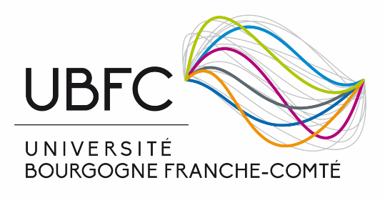
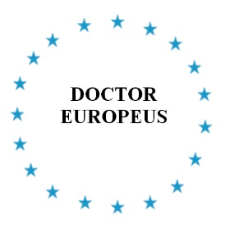

“european doctorate” label

In order to promote PhD student mobility, the Direction of Research and of Doctoral Studies of the Université Bourgogne Franche-Comté (UBFC) institution delivers a “European doctorate” label.
This label is not defined by a regulatory text, and remains based on the institution’s initiative. The label has already been awarded in several French universities since 1992 (Montpellier, La Rochelle, Lille, Limoges, Aix-Marseille, Nice, Lyon, etc.).
Application for the label is submitted before defence and is reserved to PhD students enrolled in universities in the 28 European Union countries¹, plus the other European free-exchange states (Switzerland, Iceland, Norway, Liechtenstein). It is a qualification that should not be mistaken with international administrative co-supervision of theses, yet which can come in addition to it.
The “European doctorate” consists of a certificate added to the doctoral degree, awarded by UBFC and signed by its president.
The “European doctorate” is awarded when students comply with the four criteria established by the former Confederation of European Union Rectors' Conference (now European University Association):
- before defence, the works are examined by two reporter colleagues habilitated to direct research and belonging to two institutions other than UBFC, including at least one non-French European one. The reports will clearly mention that the research works are eligible to the award of a doctor’s degree, and will reach the doctoral school four weeks before defence

- jury composition is defined by texts, with at least one jury member belonging to a higher education institution other than UBFC, from a European state

- at least part of defence will be done in a national European language other than the national language of the country where the doctor’s degree was prepared

- the PhD student will have spent at least three months doing research in a member state of the European Union.

Administrative procedure
The request will be filed in on ADUM, at the time of the launching of the defence preparation. Additional documents must be submitted in a signle PDF file. Application will be validated by the doctoral school when the list of jury reporters and members is submitted.
Authorisation to write and defend in another European language than French will be granted by the doctoral school director. If the thesis manuscript is written in another European language than French, an abstract of a significant size will have to be written in French.
Besides, the defence report established by the president of the jury will specify that defence was done in another European Union language than French so that the European label may be awarded.
The committee granting the “European doctorate” label mentions it in the defence transcript. Then a certificate is delivered to the student concomitantly with his/her certificate of doctoral thesis achievement.

